Webanhang

Software Development Plan

Version 0.1

Revision History

| **Date** | **Version** | **Description** | **Author** |
| --- | --- | --- | --- |
| 11/11/2022 | 0.1 | Preliminary Software Development Plan | Đỗ Thuỵ Phương Vy |
|  |  |  |  |
|  |  |  |  |
|  |  |  |  |

Table of Contents

**1. Introduction** **4**

**2. Project Overview** **4**

*2.1 Project Purpose, Scope, and Objectives* *4*

*2.2 Assumptions and Constraints* *4*

*2.3 Project Deliverables* *4*

**3. Project Organization** **4**

*3.1 Organizational Structure* *4*

*3.2 Roles and Responsibilities* *4*

**4. Management Process** **5**

*4.1 Project Estimates* *5*

*4.2 Project Plan* *5*

**Preliminary software architecture report** **6**

**Test plan and test cases** **6**

**Deploy production** **6**

4.2.1 Phase and Iteration Plan 6

4.2.2 Releases 6

4.2.3 Project Schedule 6

*4.3 Project Monitoring and Control* *7*

4.3.1 Reporting 7

4.3.2 Risk Management 7

4.3.3 Configuration Management 7

Software Development Plan

# 

# Introduction

* The purpose of this Software Development Plan is to define the team organization, the development activities in the start-up phase, and the iterative steps required to implement the project development.

# Project Overview

## Project Purpose, Scope, and Objectives

* The purpose of the project is to create an e-commerce site where sellers can sell items they own in Viet Nam.
* The goal of this project is to be able to deliver all the features as planned.

## Assumptions and Constraints

* Project has a fixed schedule of 12 weeks.
* Zero-budget project.
* The project has 5 people, there will be no more people added during the project.

## Project Deliverables

* The following deliverables will be produced during the project:
* Creative Design Briefs
* Navigation Map
* User Interface Prototype
* Use Case Survey
* Data Model
* Design Model
* Database Design
* Software Architecture Document
* Change Requests
* Test Summary

# Project Organization

## Organizational Structure

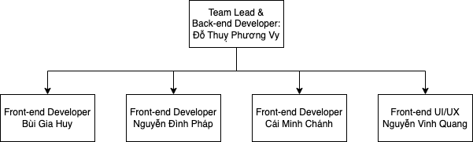

## Roles and Responsibilities

The following table shows responsibilities of each role listed above in Organizational Structure.

| **Role** | **Responsibilities** |
| --- | --- |
| Front-end developer | Front-end developers build and develop user-facing features, decide the structure of web pages, build reusable code, debug. |
| Team leader | Team leader is responsible for managing processes. Set up clear standards and procedures of project development. Track progress of the project. Introduce clear instruction and prevent issues from arising. |
| Back-end developer | Back-end developers build a mechanism for what to do with the data (end-user’s data) and how the system will respond when receiving the data. Manage data storage, security and other functions of the website that aren’t visible to the end-user. |
| UI/UX | Design user interface for the website. Form designing ideas gathered from the website’s requirements. |

# Management Process

## Project Estimates

* The Inception phase of this project will take 2 sprints (4 weeks).

## Project Plan

| **Task** | **Start** | **End** |
| --- | --- | --- |
| Start project - Sprint 1 planning | 31/10/2022 | 31/10/2022 |
| Preliminary project planning report, vision document | 31/10/2022 | 14/11/2022 |
| Create tasks for next sprints | 31/10/2022 | 14/11/2022 |
| Project planning report and vision document reviewed, updated and signed off | 14/11/2022 | 26/11/2022 |
| Preliminary Use Case Report | 14/11/2022 | 26/11/2022 |
| Develop project (15% - 30%) | 14/11/2022 | 28/11/2022 |
| Use Case Report reviewed, updated and signed off | 26/11/2022 | 10/12/2022 |
| Preliminary software architecture report | 26/11/2022 | 10/12/2022 |
| Develop project (50% - 60%) | 28/11/2022 | 12/12/2022 |
| SAD reviewed, updated and signed off | 10/12/2022 | 24/12/2022 |
| User Interface Prototype created, reviewed, and signed off | 10/12/2022 | 24/12/2022 |
| Develop project (~80%) | 12/12/2022 | 26/12/2022 |
| Test plan and test cases | 24/12/2022 | 07/01/2022 |
| Deploy production | 26/12/2022 | 09/01/2022 |

### Phase and Iteration Plan

| Phase | Iteration | Start | End |
| --- | --- | --- | --- |
| Inception Phase | Preliminary Iteration | 31/10/2022 | 14/11/2022 |
| Construction Phase | Develop Architectural Prototype | 14/11/2022 | 26/12/2022 |
| Test and release Phase | Software Release | 26/12/2022 | 09/01/2022 |

### Releases

* The website will be released as the final version on 14 January 2023 which will fall in week 11 of the first semester (2022-2023).

### Project Schedule

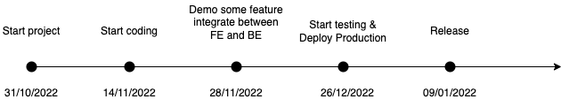

## Project Monitoring and Control

### Reporting

* Weekly meeting
* Sprint planning meeting
* Retro meeting

### Risk Management

| *Risk ID* | *Risk Description* | *Probability* | *Impact* | *Priority* | *Mitigation Strategy or Contingency Plan* |
| --- | --- | --- | --- | --- | --- |
| 1 | Can't finish pushing the full feature | 10% |  | High | Follow up on regular tasks |

### Configuration Management

* **Google Drive** for sharing files, reports, and other resources.
* **GitHub** for storing and managing source code
* **Slack** for communicating, and seeing updates on the project
* **Trello** Manage the work and track the progress of the project